Hi Siti

This is the email including images.

Some issues I faced:

1)Footer – There is no section for Section1 (If Logged out) For Customer in the back end of the staging website hence I do not know where to insert it.

Life: 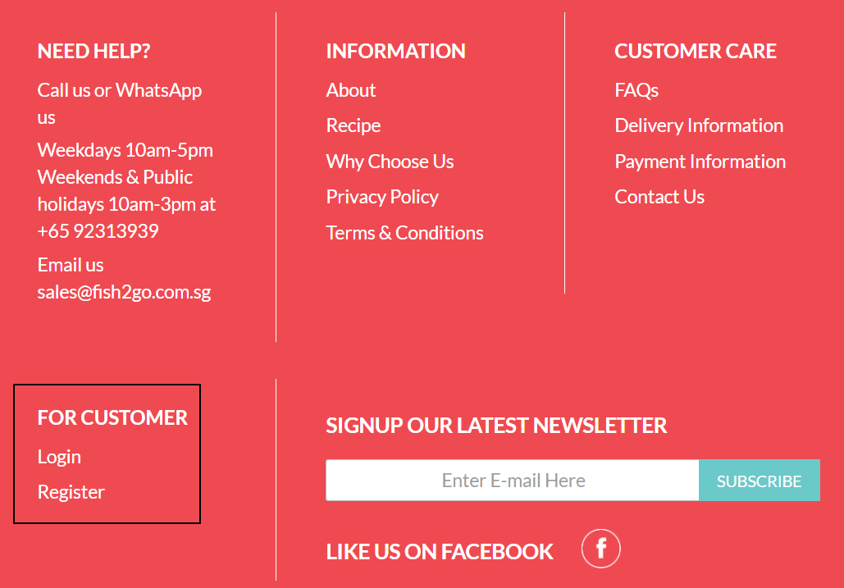

Staging: 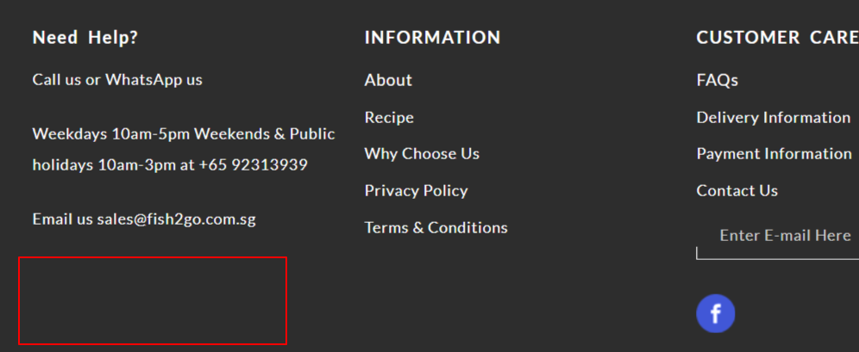

2)CMS pages – I released all pages in the live website that are already created in the staging website and the contents are the same too, but the layouts are 1-column instead of CMS Page, do I need to change to the same as the live website? e.g. Homepage for home page / CMS Page for all other pages.

Life: 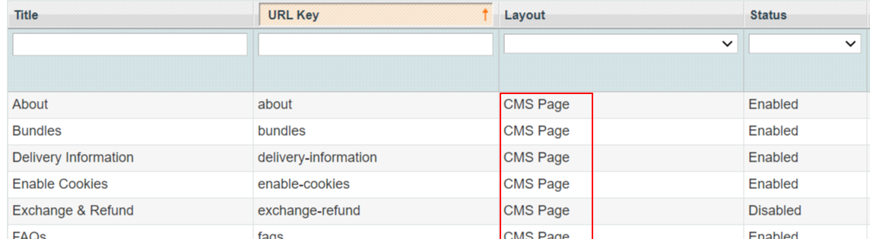

Staging: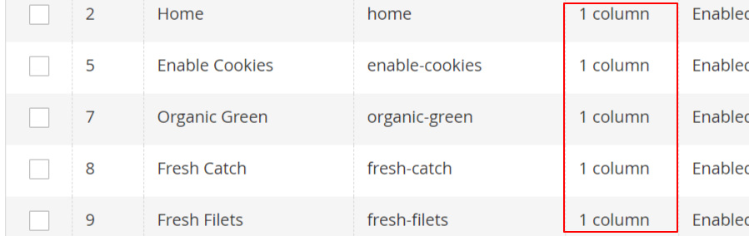

3) Header- Do I need to change the HK logo to the Fish2Go logo?

 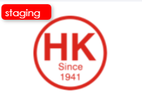

4) Shipping methods- There is no self-collection tab on the live website hence I keep it as default.

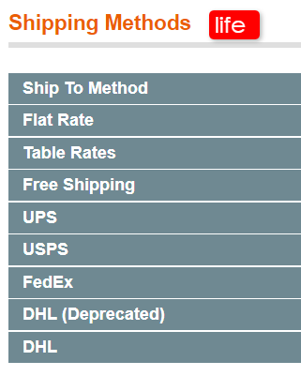 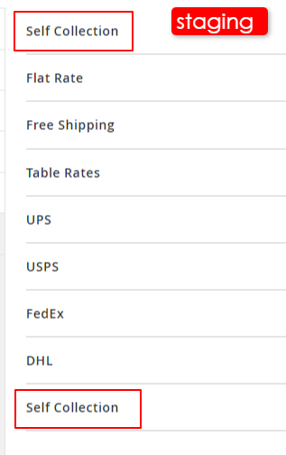

5) Payment Method- There is no Braintree payment method on the live website and I do not how to remove it.

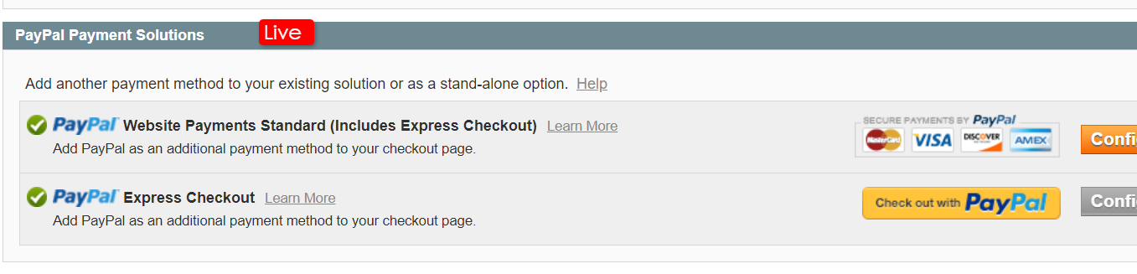

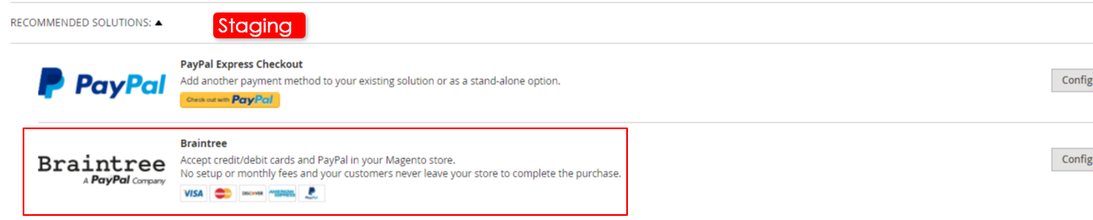

6) Home slider – I am not sure if it is the alignment issue or I did it wrongly, the banner image will not save after I click save config.

I edit the slider at Stores > configuration >Hoekee > Homepage

